**Text-to-Image Generation and Analysis Using Stable Diffusion, CLIP, and SAM2**

**Abstract**

This project demonstrates a machine learning-based solution for generating and analyzing images using natural language prompts. The system leverages state-of-the-art models, including Stable Diffusion for text-to-image generation, CLIP for image analysis, and SAM2 for segmentation. The solution is implemented as a RESTful API, providing endpoints for generating images from text prompts and analyzing images to identify relevant concepts. The API is deployed on AWS EC2 using Docker for containerization, with thorough testing and error handling mechanisms in place to ensure reliability.

**Introduction**

In recent years, advancements in machine learning have enabled powerful applications in computer vision, such as generating realistic images from text descriptions and analyzing images for content recognition. This project combines text-to-image generation with image analysis to build a system that can not only create images from textual prompts but also analyze these images for semantic content. The solution involves the integration of the Stable Diffusion model for generating images, the CLIP model for analyzing images, and SAM2 for segmenting image regions.

**Methodology**

1. **System Design**: The system comprises two main API endpoints:
   * **/generate**: Uses Stable Diffusion to generate an image from a text prompt.
   * **/analyze**: Utilizes CLIP to analyze an image for conceptual relevance, with optional segmentation using SAM2.
2. **Technologies Used**:
   * **Stable Diffusion**: A text-to-image model that generates high-quality images based on natural language prompts.
   * **CLIP (Contrastive Language–Image Pretraining)**: A model that can analyze an image and match it with relevant text descriptions.
   * **SAM2 (Segment Anything Model)**: A segmentation model that identifies regions in the image.
   * **Flask**: A Python web framework for building the RESTful API.
   * **Docker**: Used to containerize the application for deployment.
   * **AWS EC2**: Cloud hosting platform for deployment.
3. **Deployment Setup**:
   * **Docker Containerization**: The application is packaged in a Docker container for easy deployment.
   * **AWS EC2 Deployment**: The container is hosted on an AWS EC2 instance with the necessary configurations for running the API.

**Implementation**

1. **Generate Endpoint (/generate)**:
   * Accepts a JSON request with a "prompt" field.
   * Uses Stable Diffusion to generate an image based on the text prompt.
   * Saves the generated image and returns a URL for accessing it.

Input :  
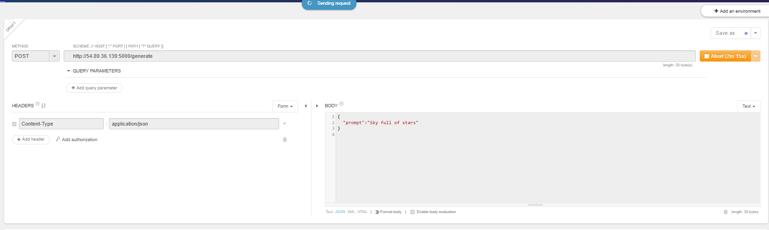



Output :

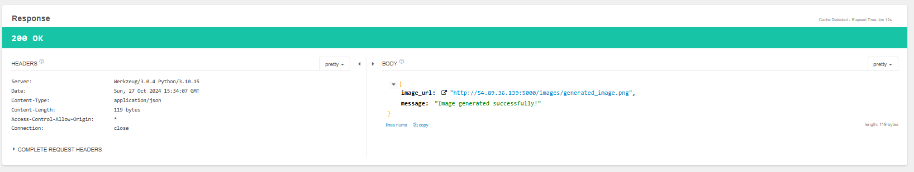

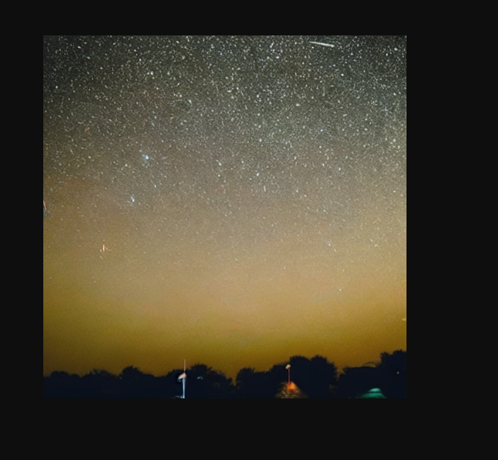

1. **Analyze Endpoint (/analyze)**:
   * Accepts a JSON request with an "image_url" field.
   * Downloads the image from the provided URL.
   * Performs image analysis using CLIP to identify matching concepts.
   * Optionally performs segmentation using SAM2 and returns masks and scores.

Input :  
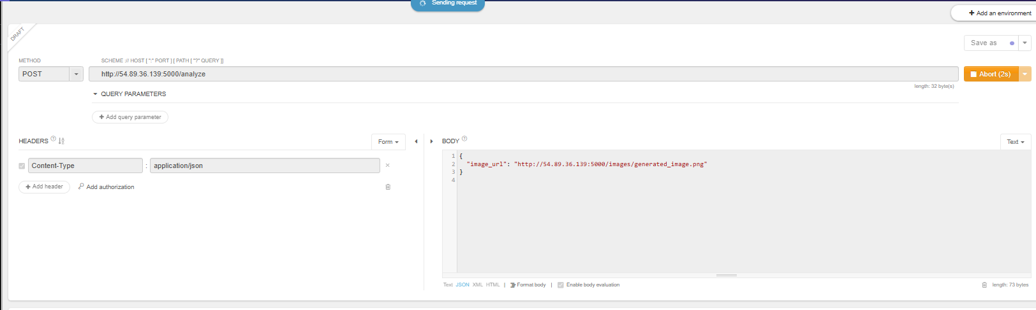

Output:

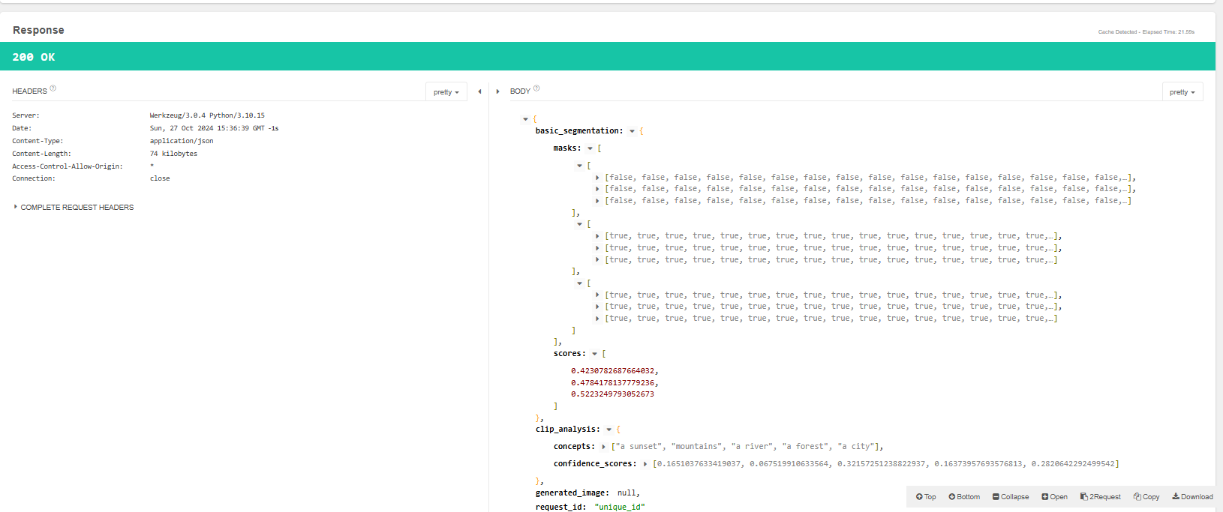

UI :  
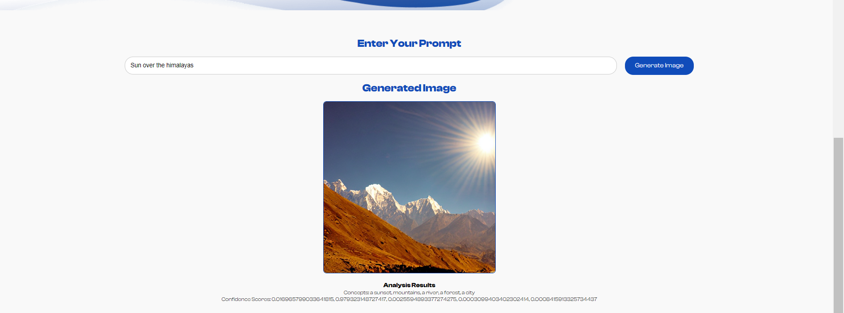

1. **Error Handling and Validation**:
   * Includes checks for missing fields in requests.
   * Validates prompt and URL formats.
   * Handles download failures and segmentation errors.

**Results**

The system successfully generates images from text prompts and performs semantic analysis. Testing shows the system can identify relevant concepts in generated images, and SAM2 segmentation provides masks that can be used for further analysis.

**Discussion**

The combination of Stable Diffusion, CLIP, and SAM2 provides a powerful framework for text-to-image generation and image analysis. The results demonstrate the system's potential in fields like content creation, computer-aided design, and automated image annotation. However, the project faced challenges, such as handling large model sizes and optimizing inference times.

**Conclusion**

The project successfully implemented a text-to-image generation and analysis system using state-of-the-art models. The RESTful API allows for easy integration into various applications, showcasing the potential of combining multiple deep learning models for comprehensive computer vision tasks.

**Future Work**

1. **Improving Segmentation**: Fine-tune SAM2 for better segmentation results.
2. **Performance Optimization**: Implement model compression techniques to reduce model size.
3. **Adding More Analysis Features**: Extend the /analyze endpoint to support object detection and other vision tasks.